**1)pwd**

It displays the full pathname of the current working directory.

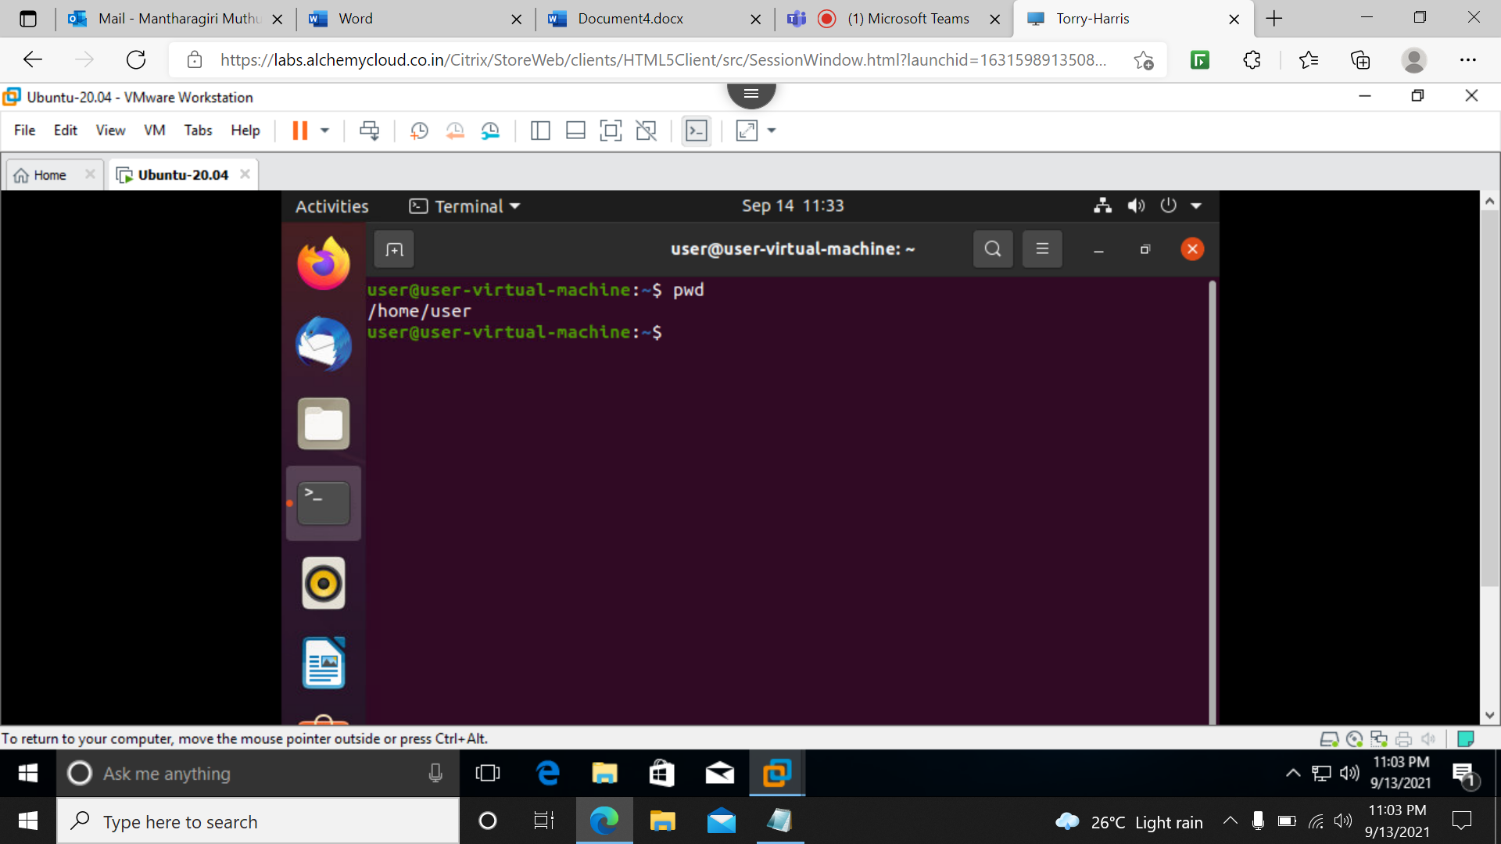

**2)clear**

It is used to clear the screen.

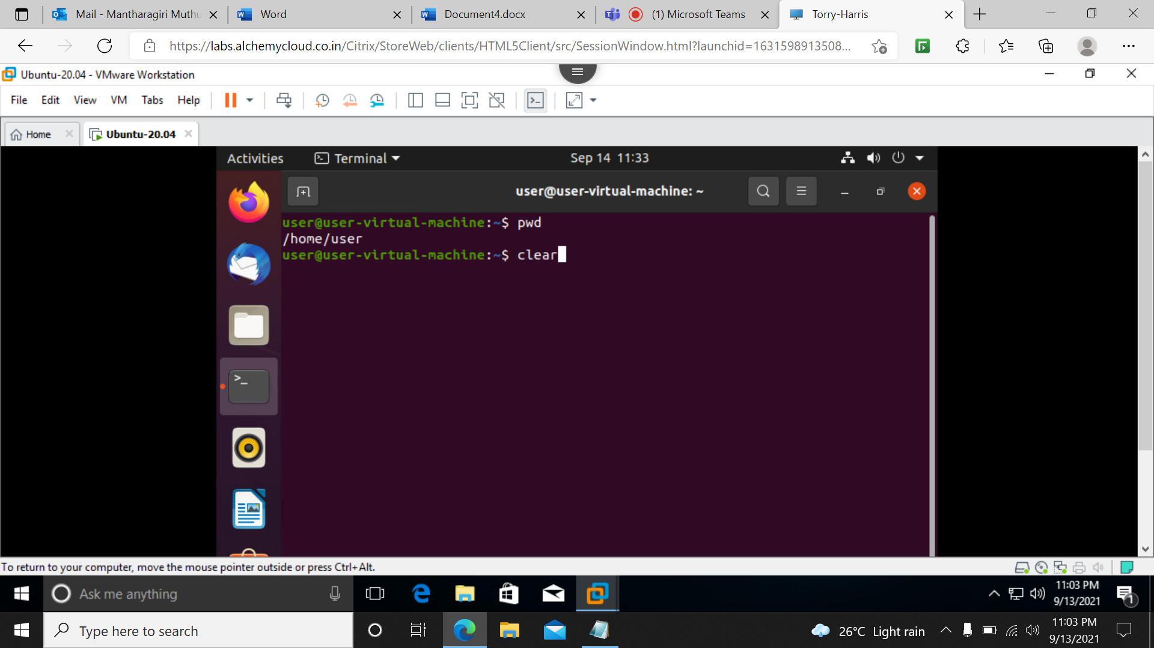

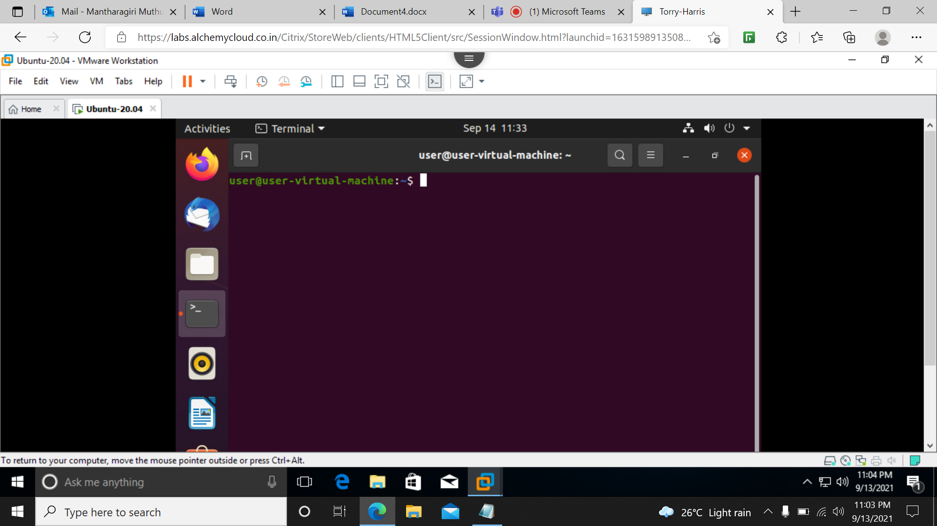

**3)ls**

It will list all files and folders in the working directory.

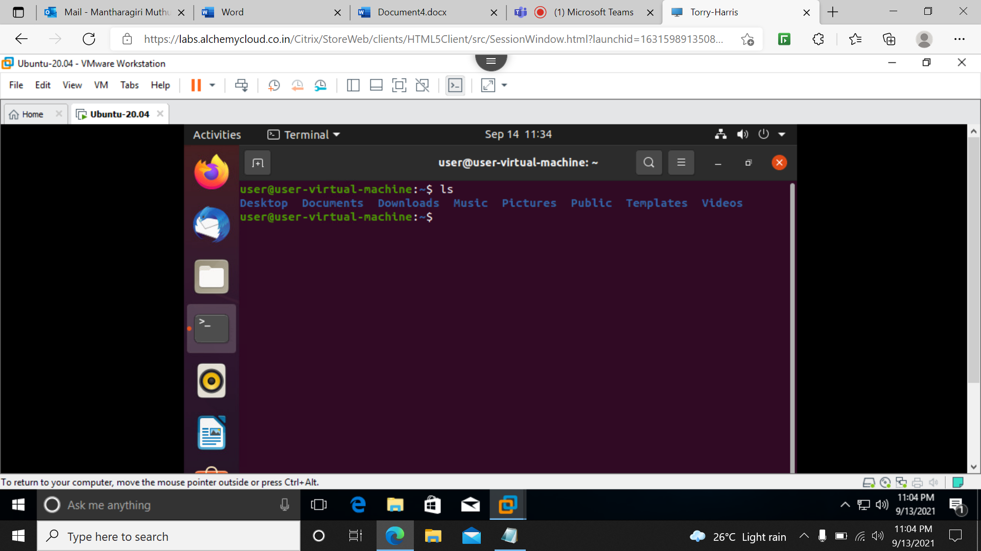

**4)ls –l**

It shows all the files in the long list format.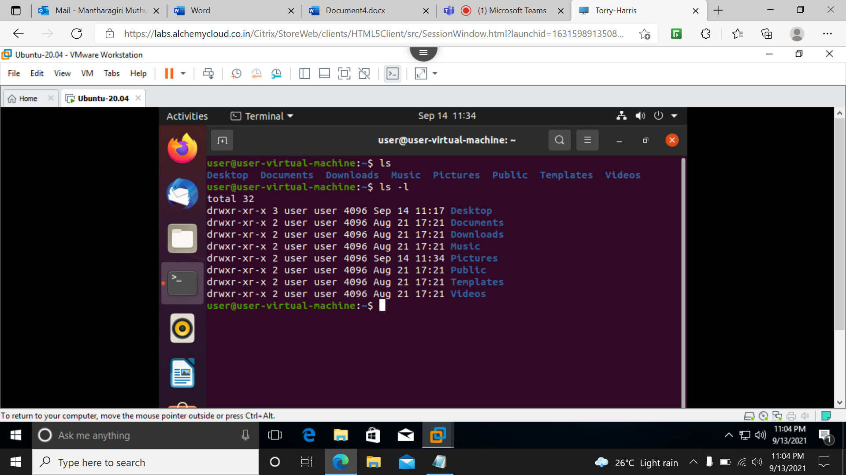

**5)cd**

It used to change the current working directory.

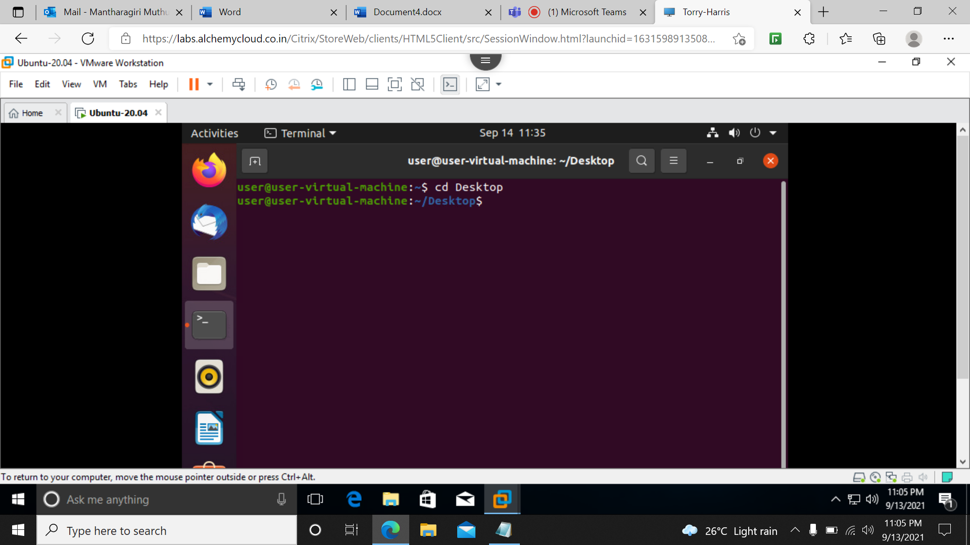

**6)ls –f**

List all the files including hidden files without any format.

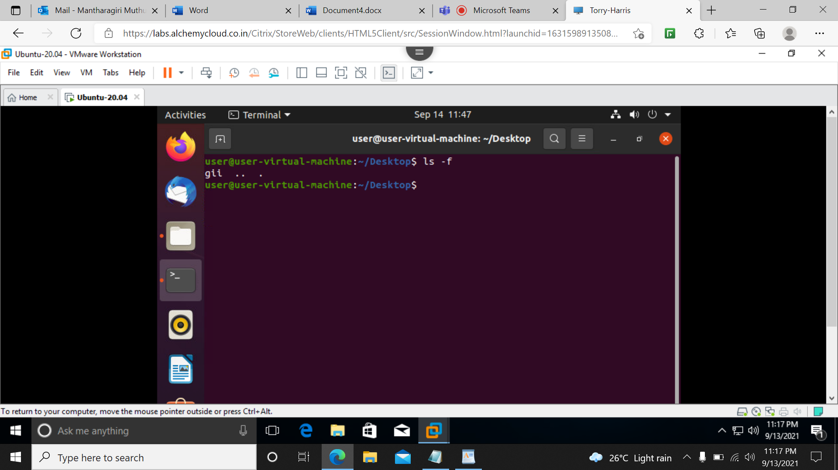

**7)ls –a**

Display all the files including hidden files in a color format.

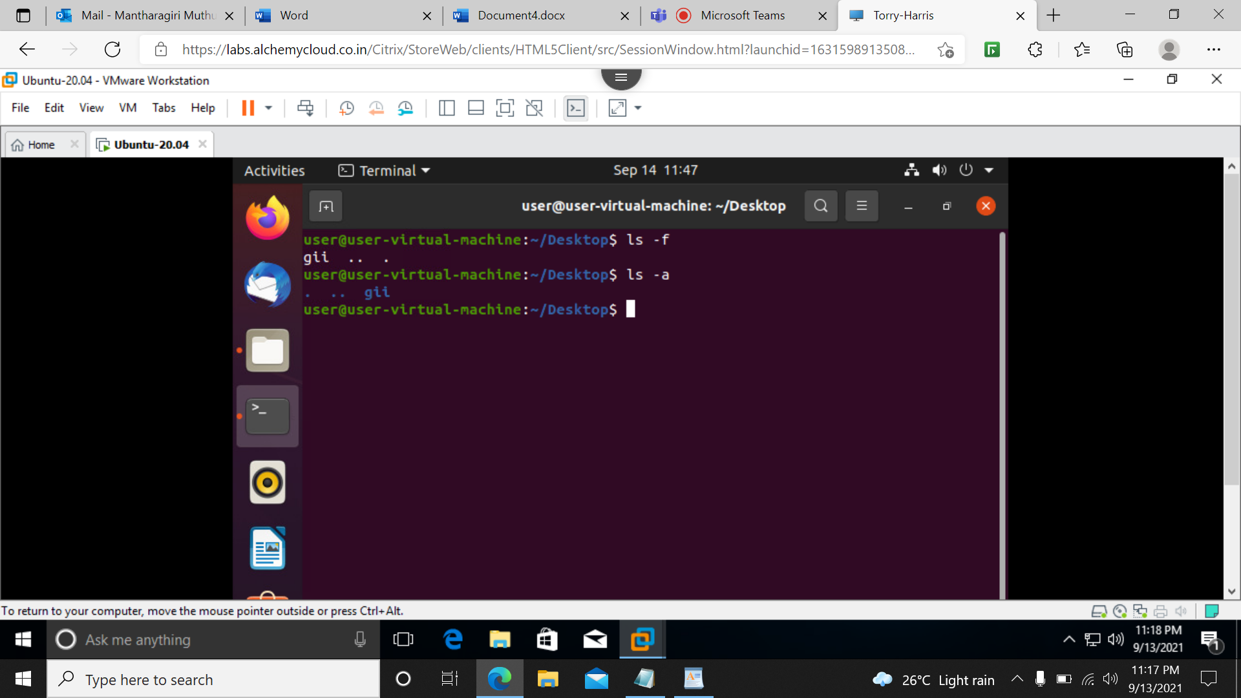

**8)cd ..**

It is used to change the directory one level up from the current directory.

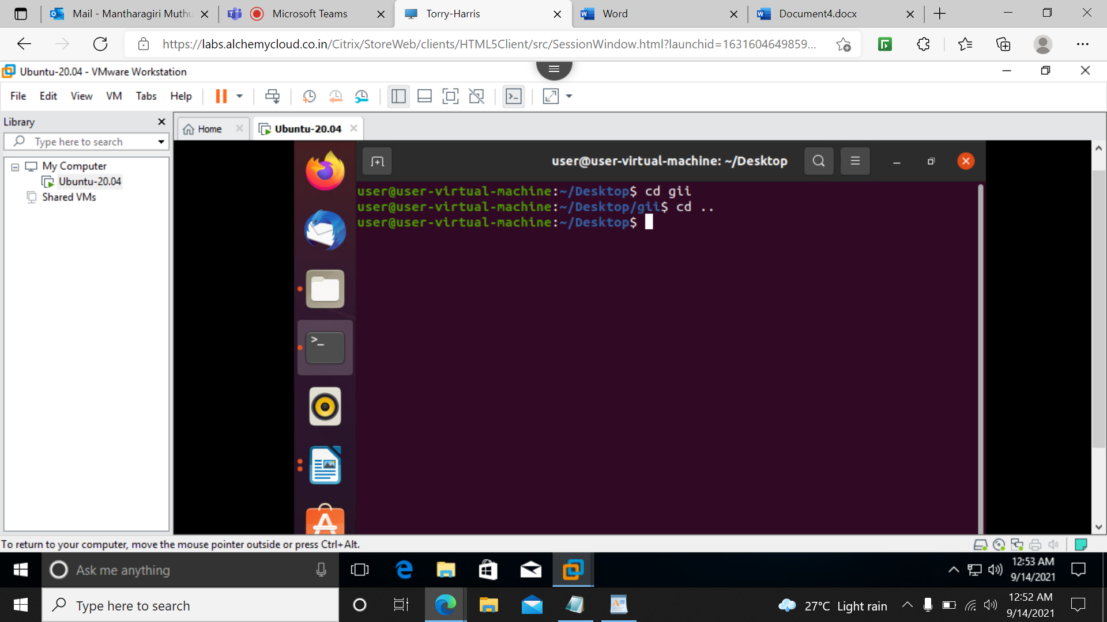

**9)Cd**

It will change to the home directory.

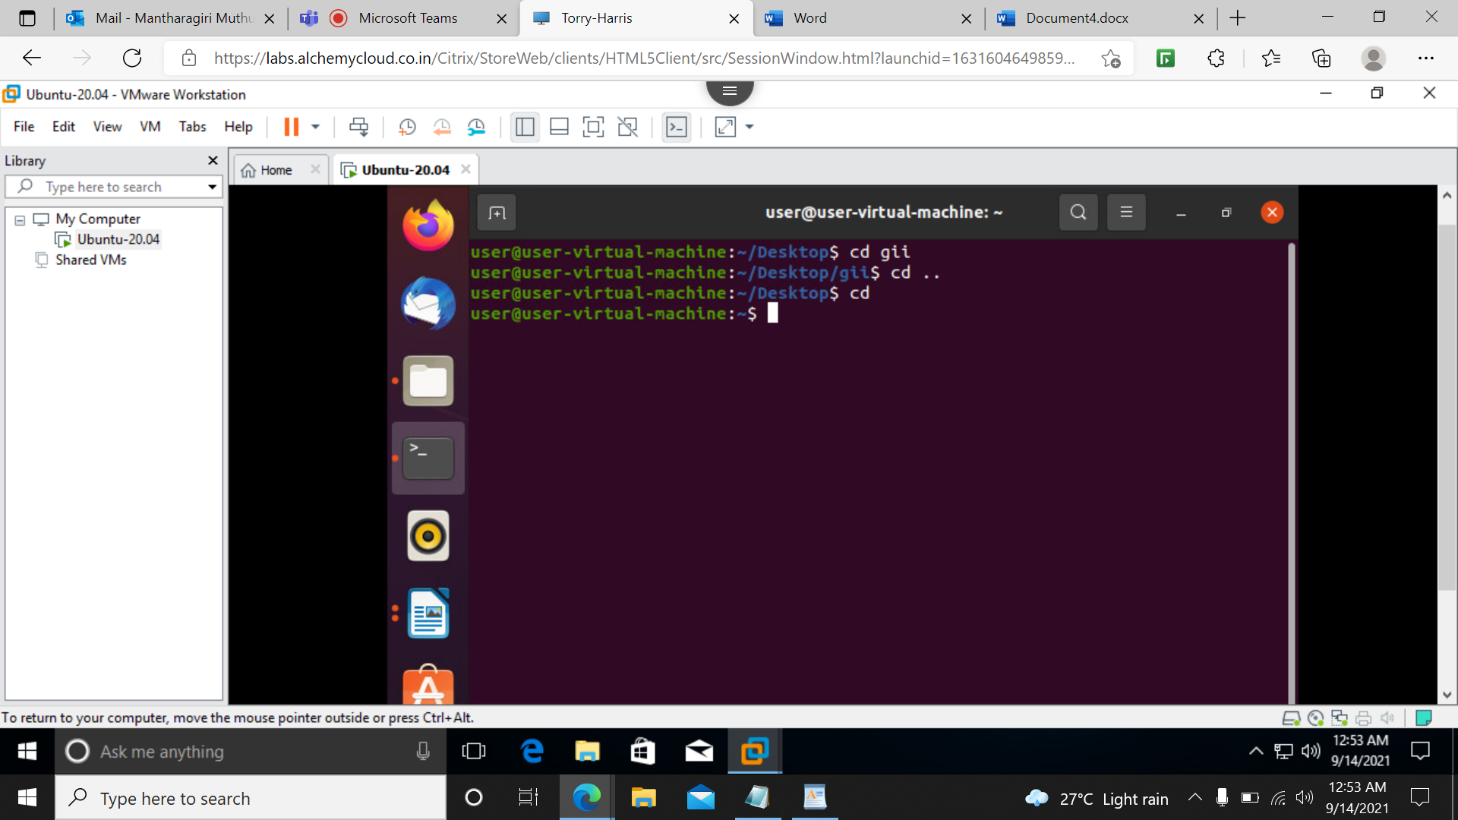

**10)Cd /**

To change into root directory.

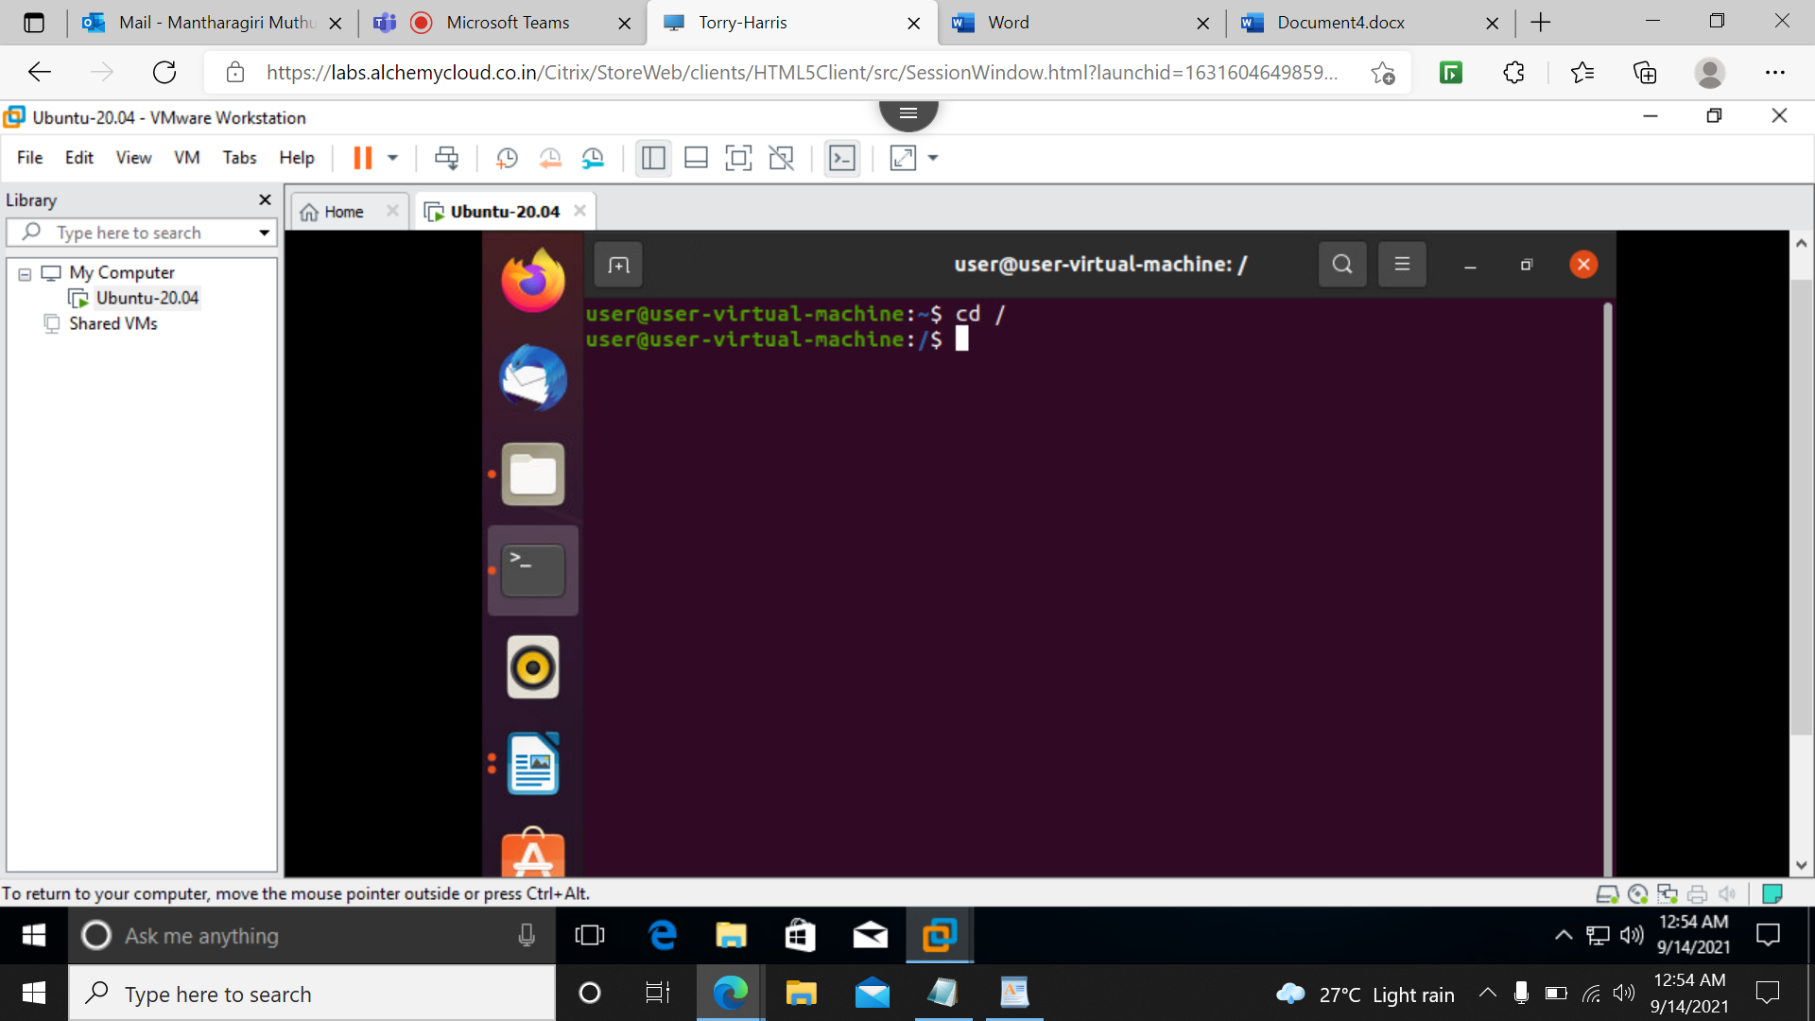

**11)mkdir**

To create a new directory.

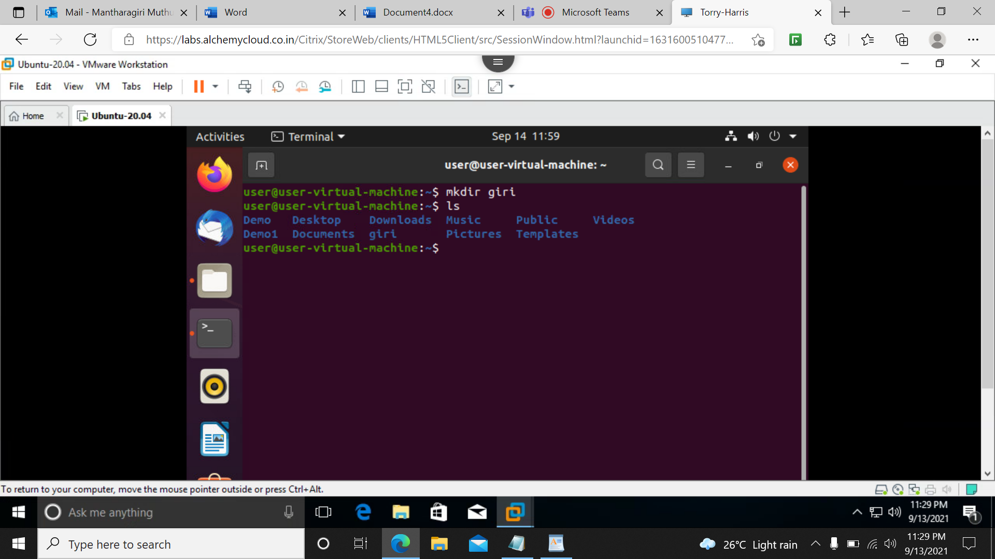

**12)rmdir**

To remove the directory.

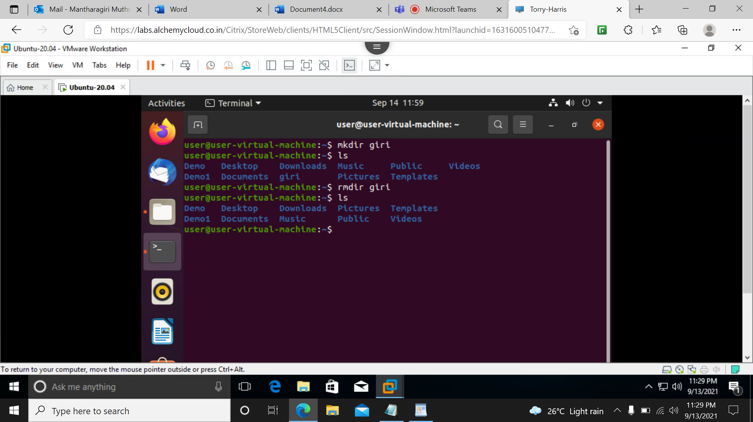

**13)mv**

It is used to rename the folders.

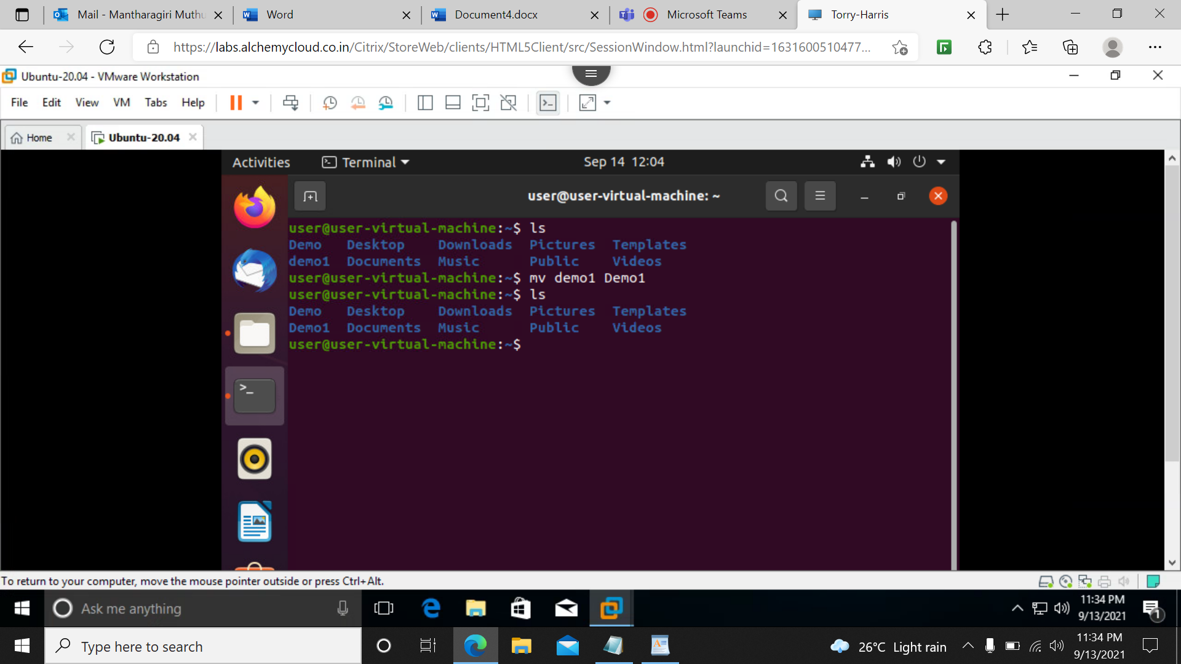

**14)cat**

It is used to view the contents of files on the standard output.

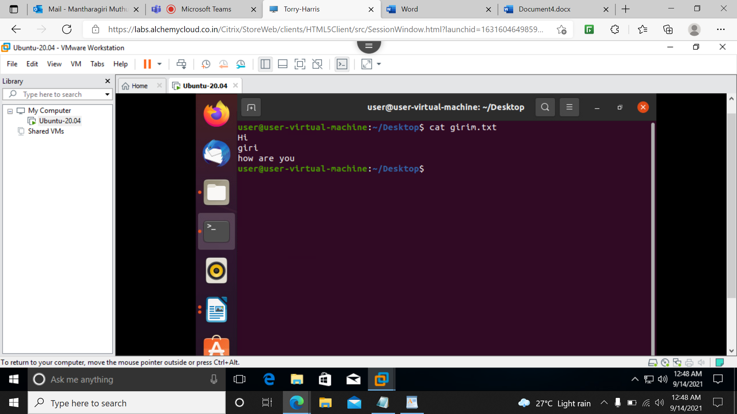

**15)touch**

It is used to create a new file.

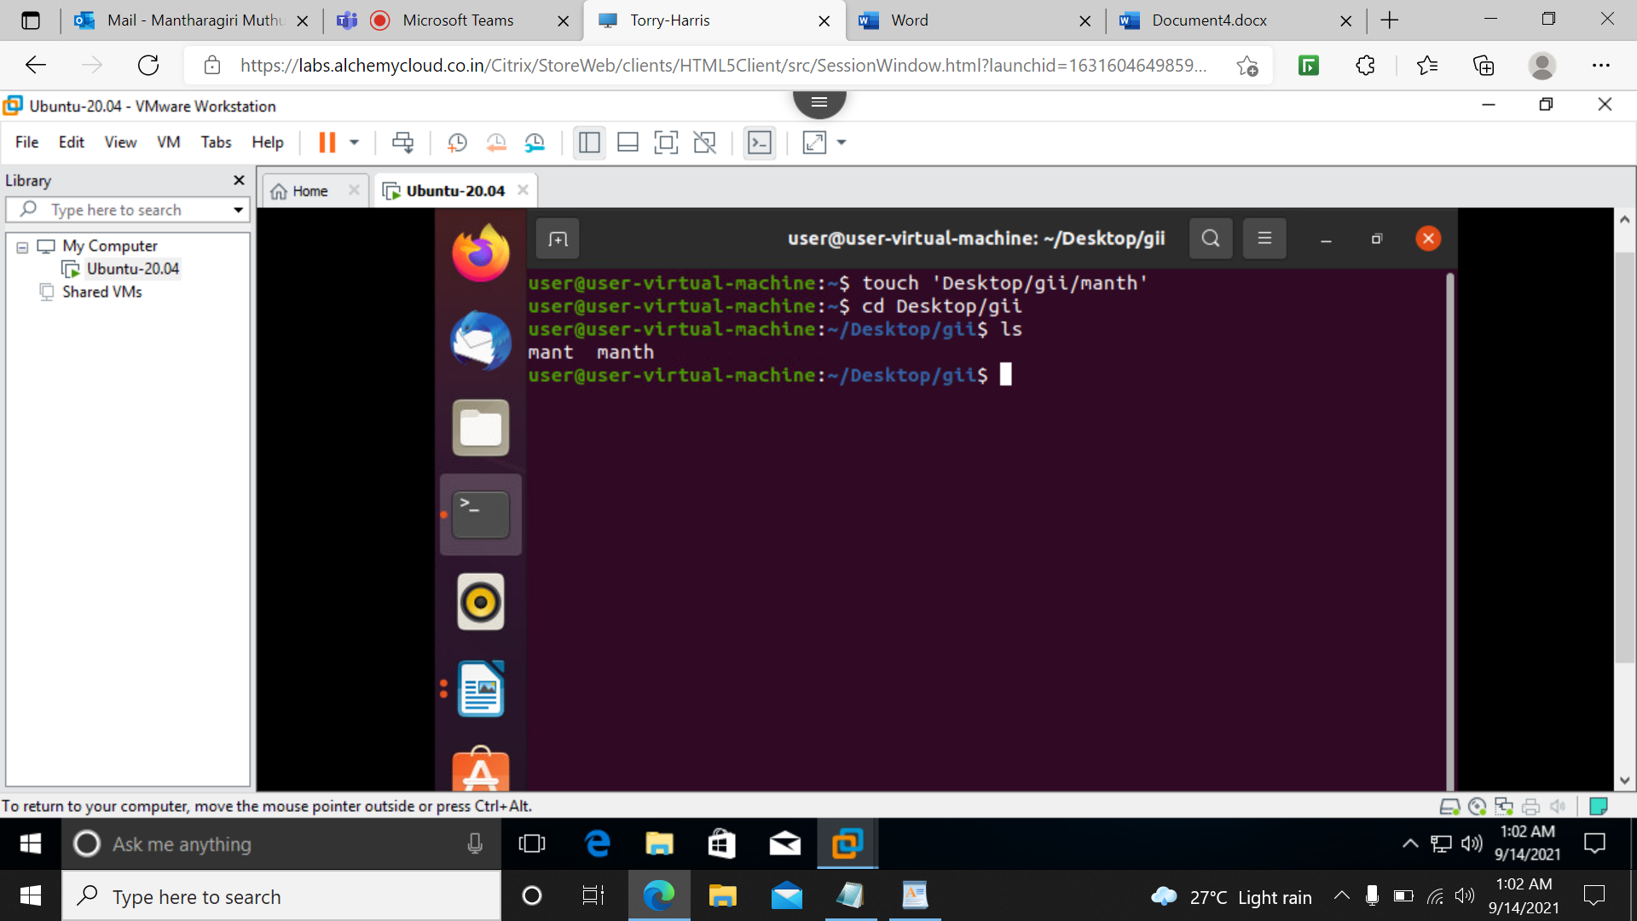

**16)rm**

To remove the file.

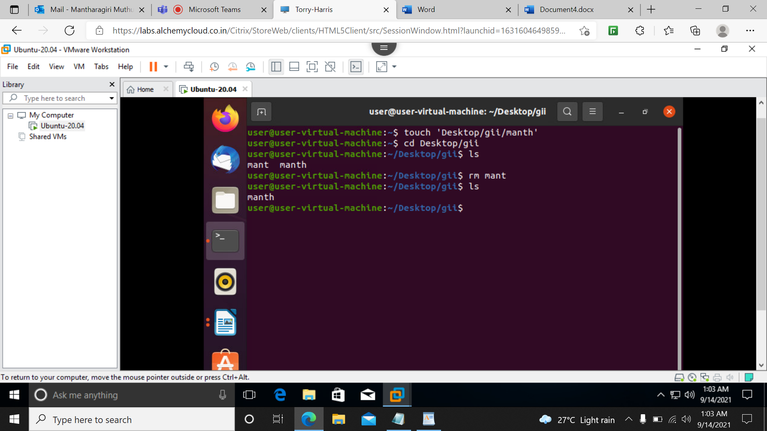

**17)cp**

To copy files and folders from one place to another.

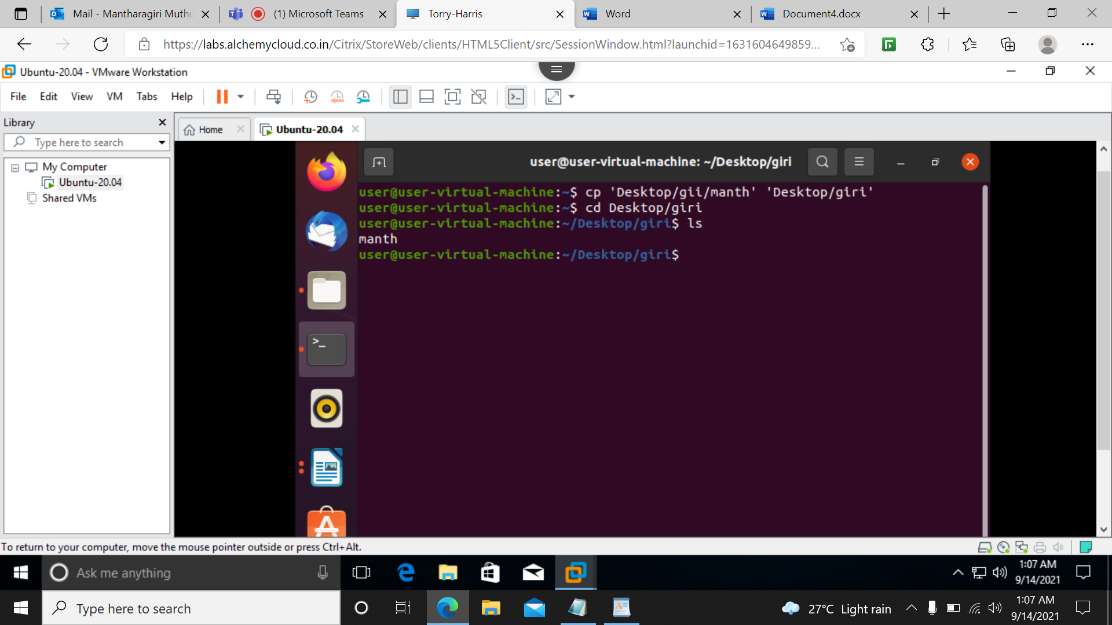

**18)cat –b**

It will display the line numbers.

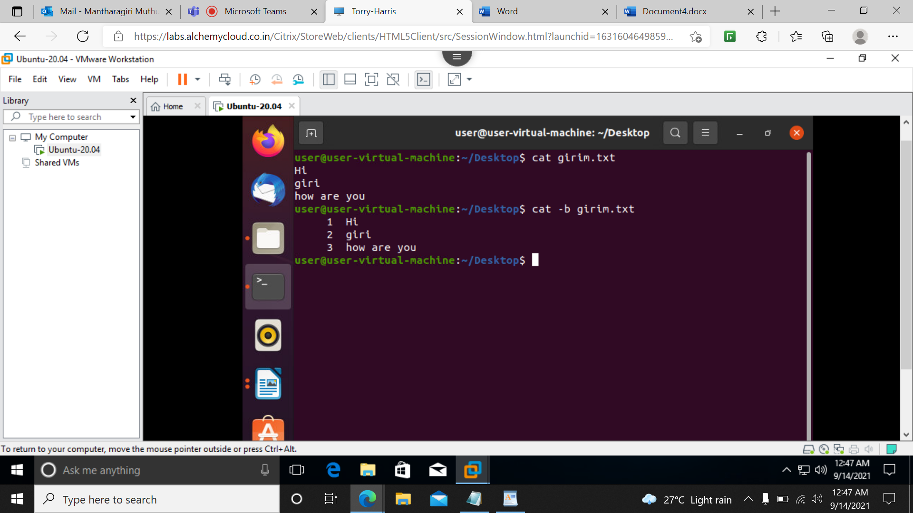

**19)Tac**

Tac is opposite to cat, it display the contents in a reverse order that is last line is displayed first and so on.

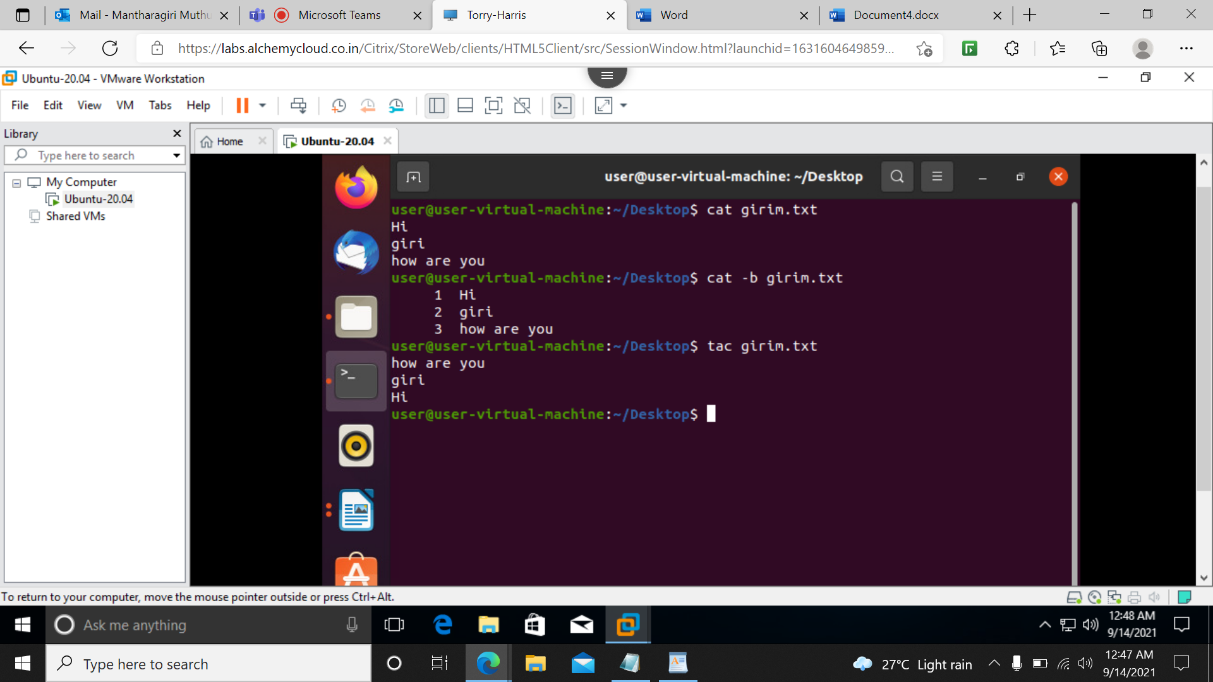

**20)Sort**

It sorts the contents of a text file, line by line.

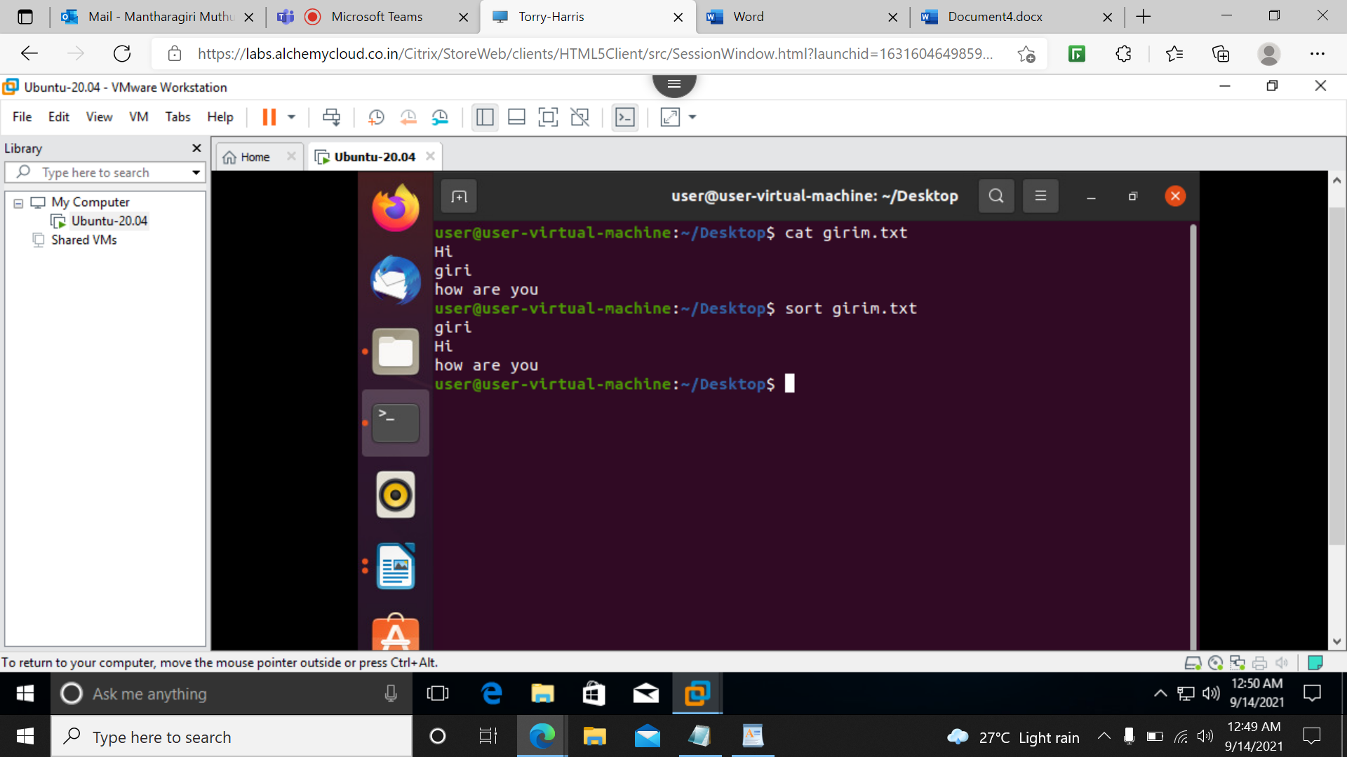

**21)who**

It will display the current user and session**.**

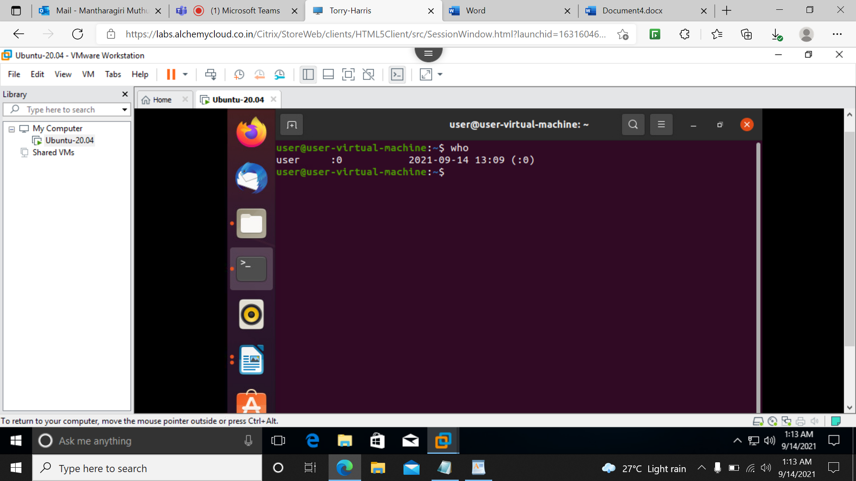

**22)echo**

It displays the string that passes as an argument.

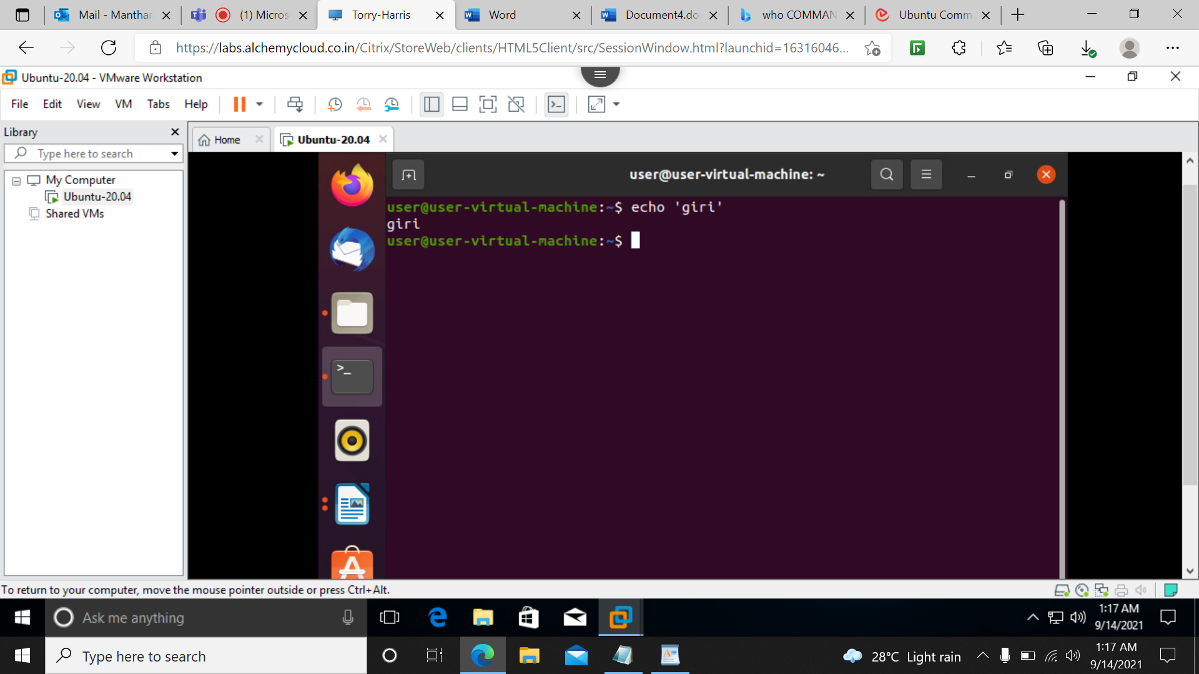

**23)ls-lr**

It display all the files in a reverse order in long format.

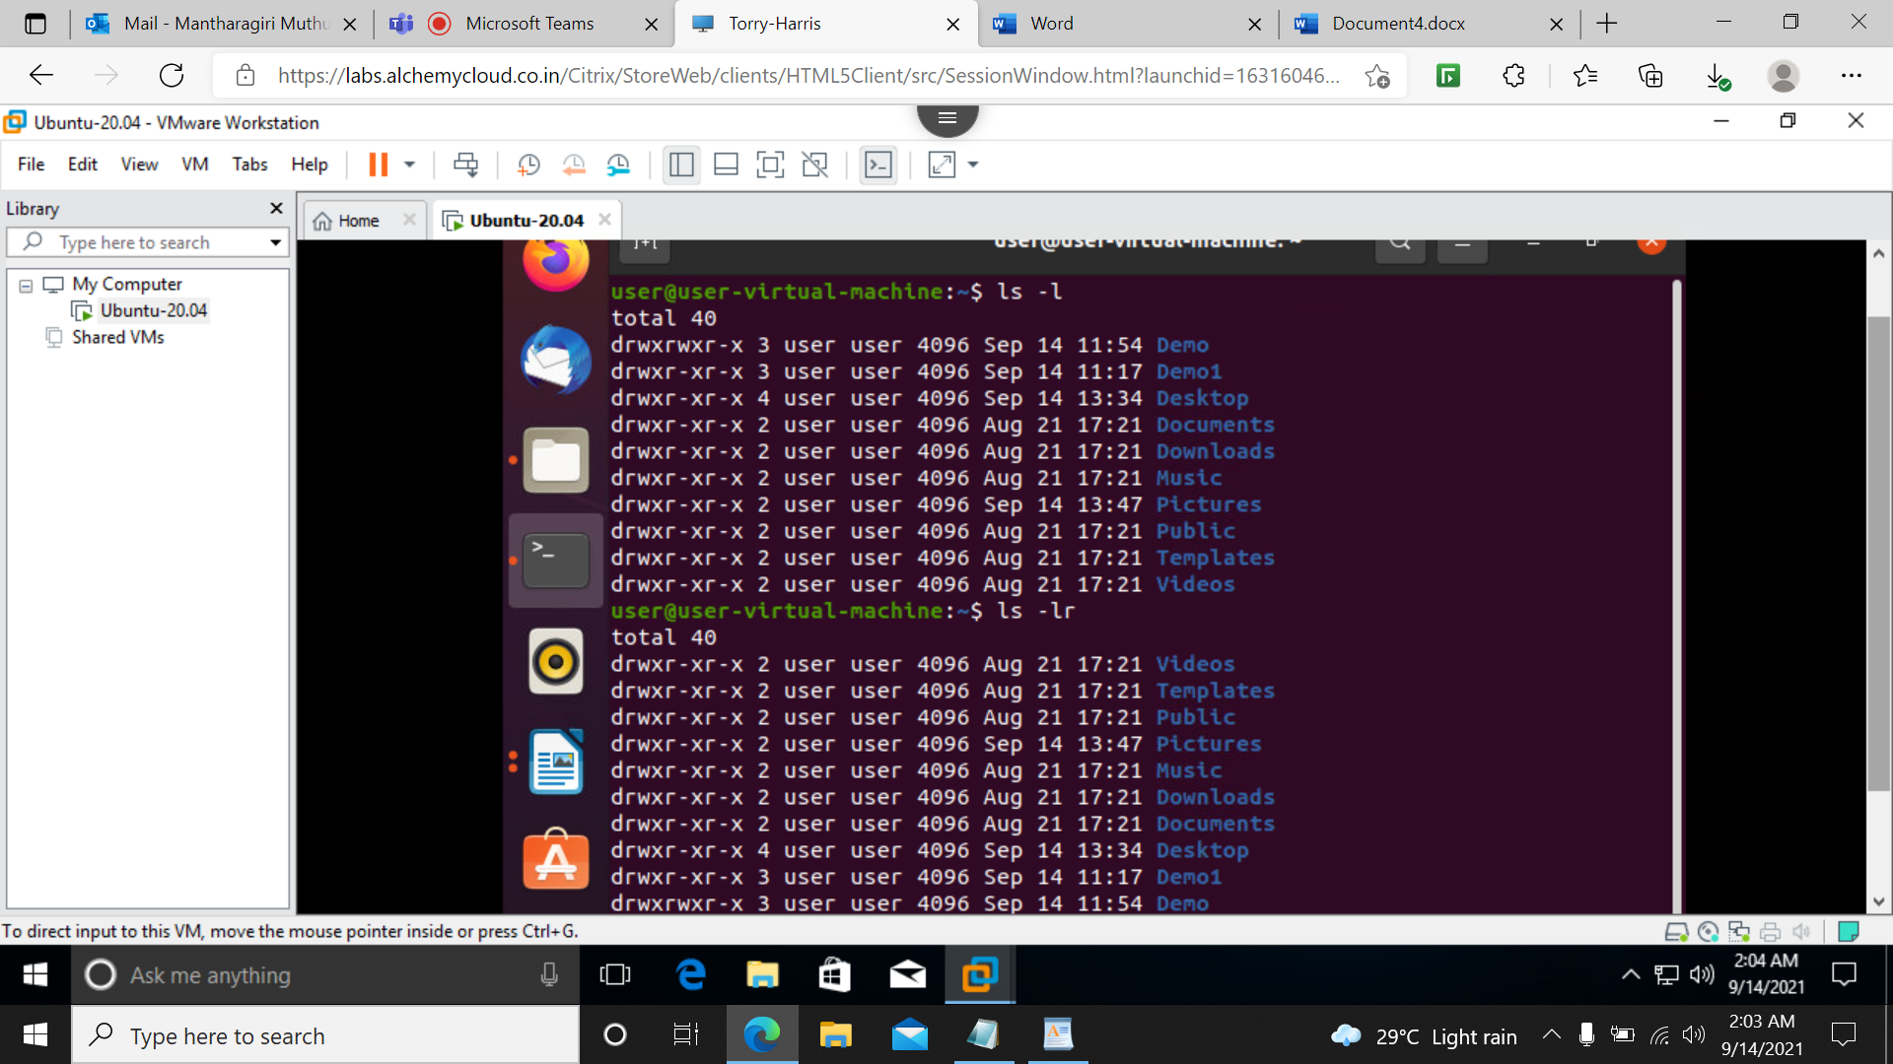

**24)ls –lar**

It display all the files including hidden files in long format in the reverse order.

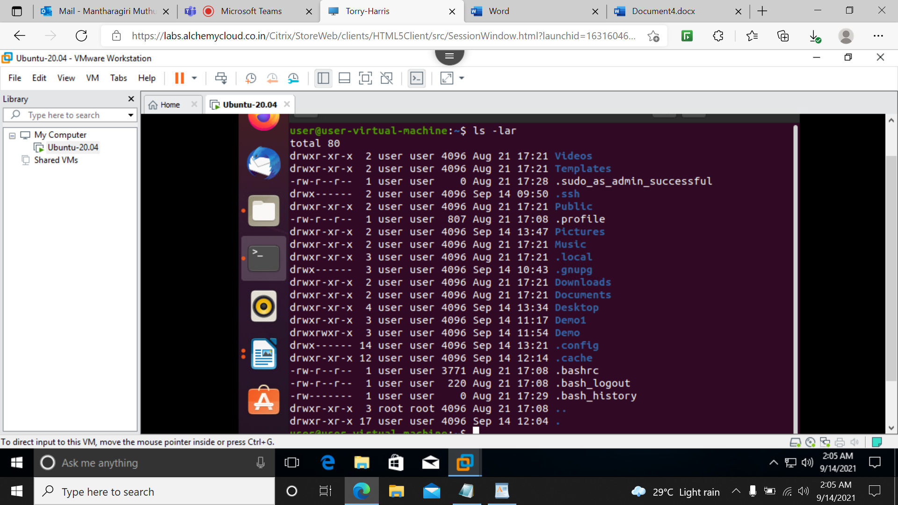

**25)man**

It display a manual page of the command,it is very detailed and we read the man pages of the command which we are unfamilar with**.**

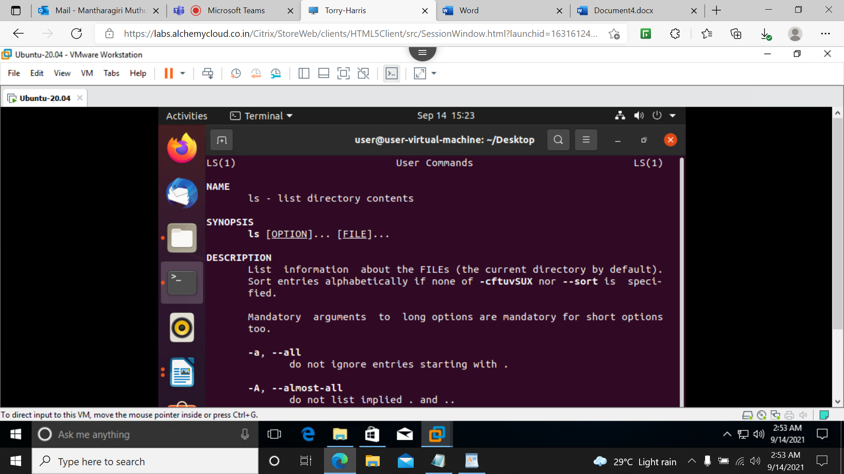

**26)date**

It displays the date and time.

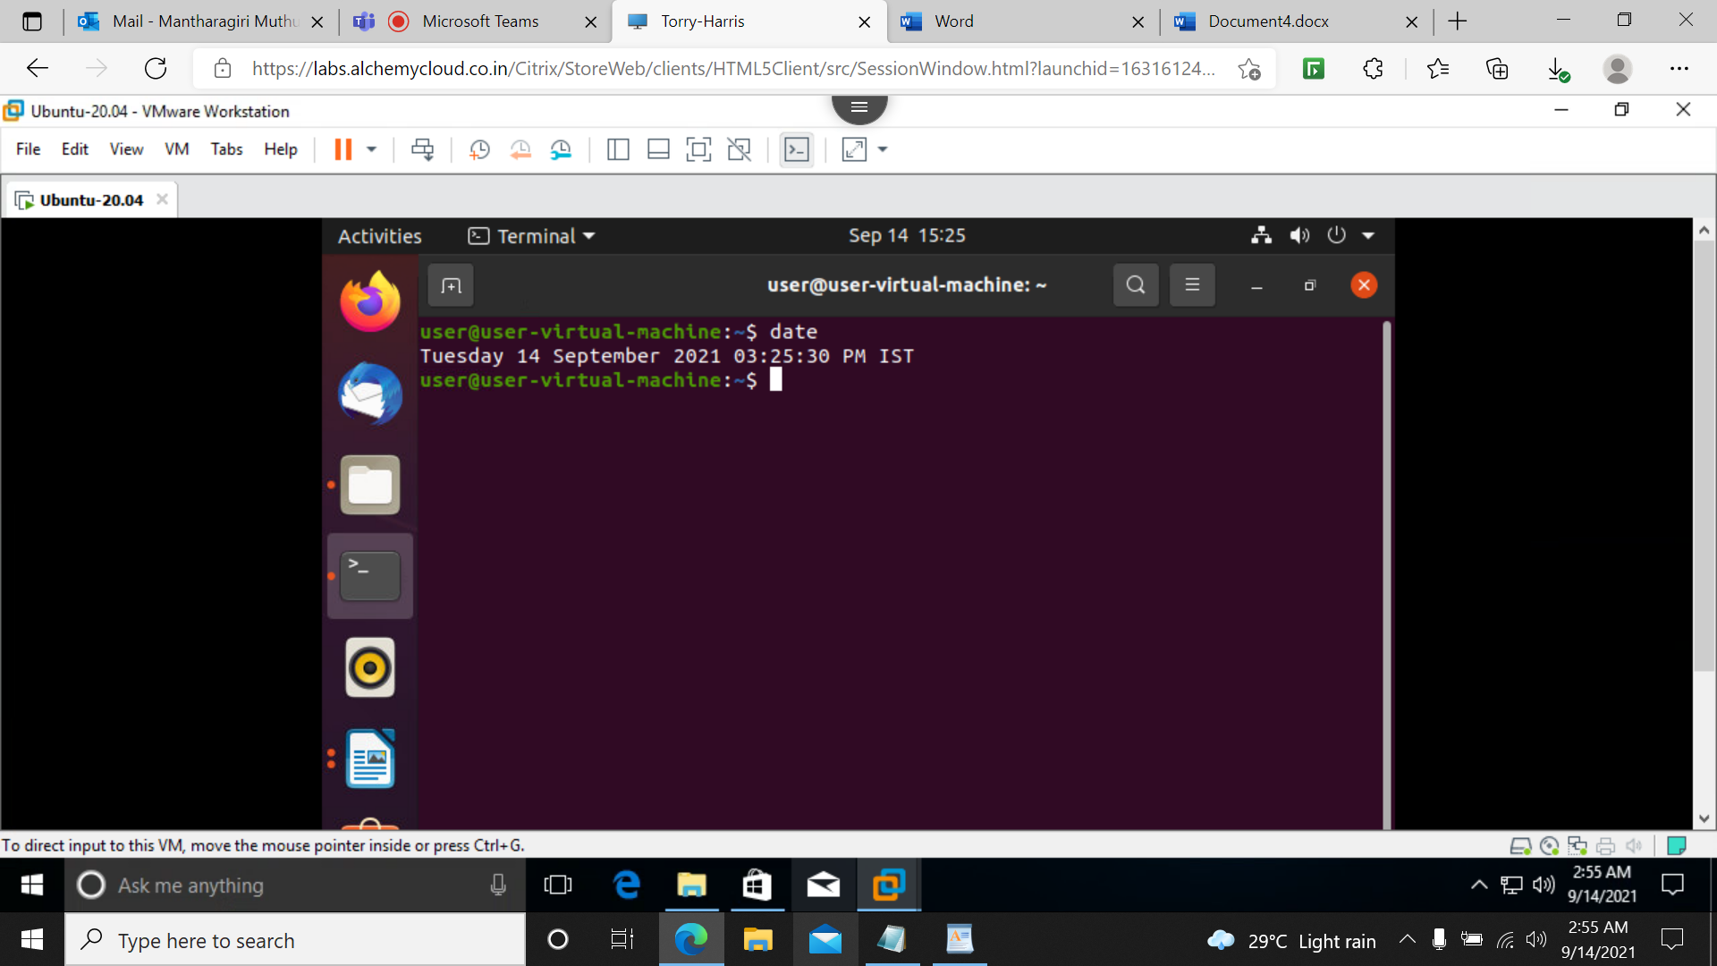

**27)cal**

It displays the current month calender with current day highlighted.

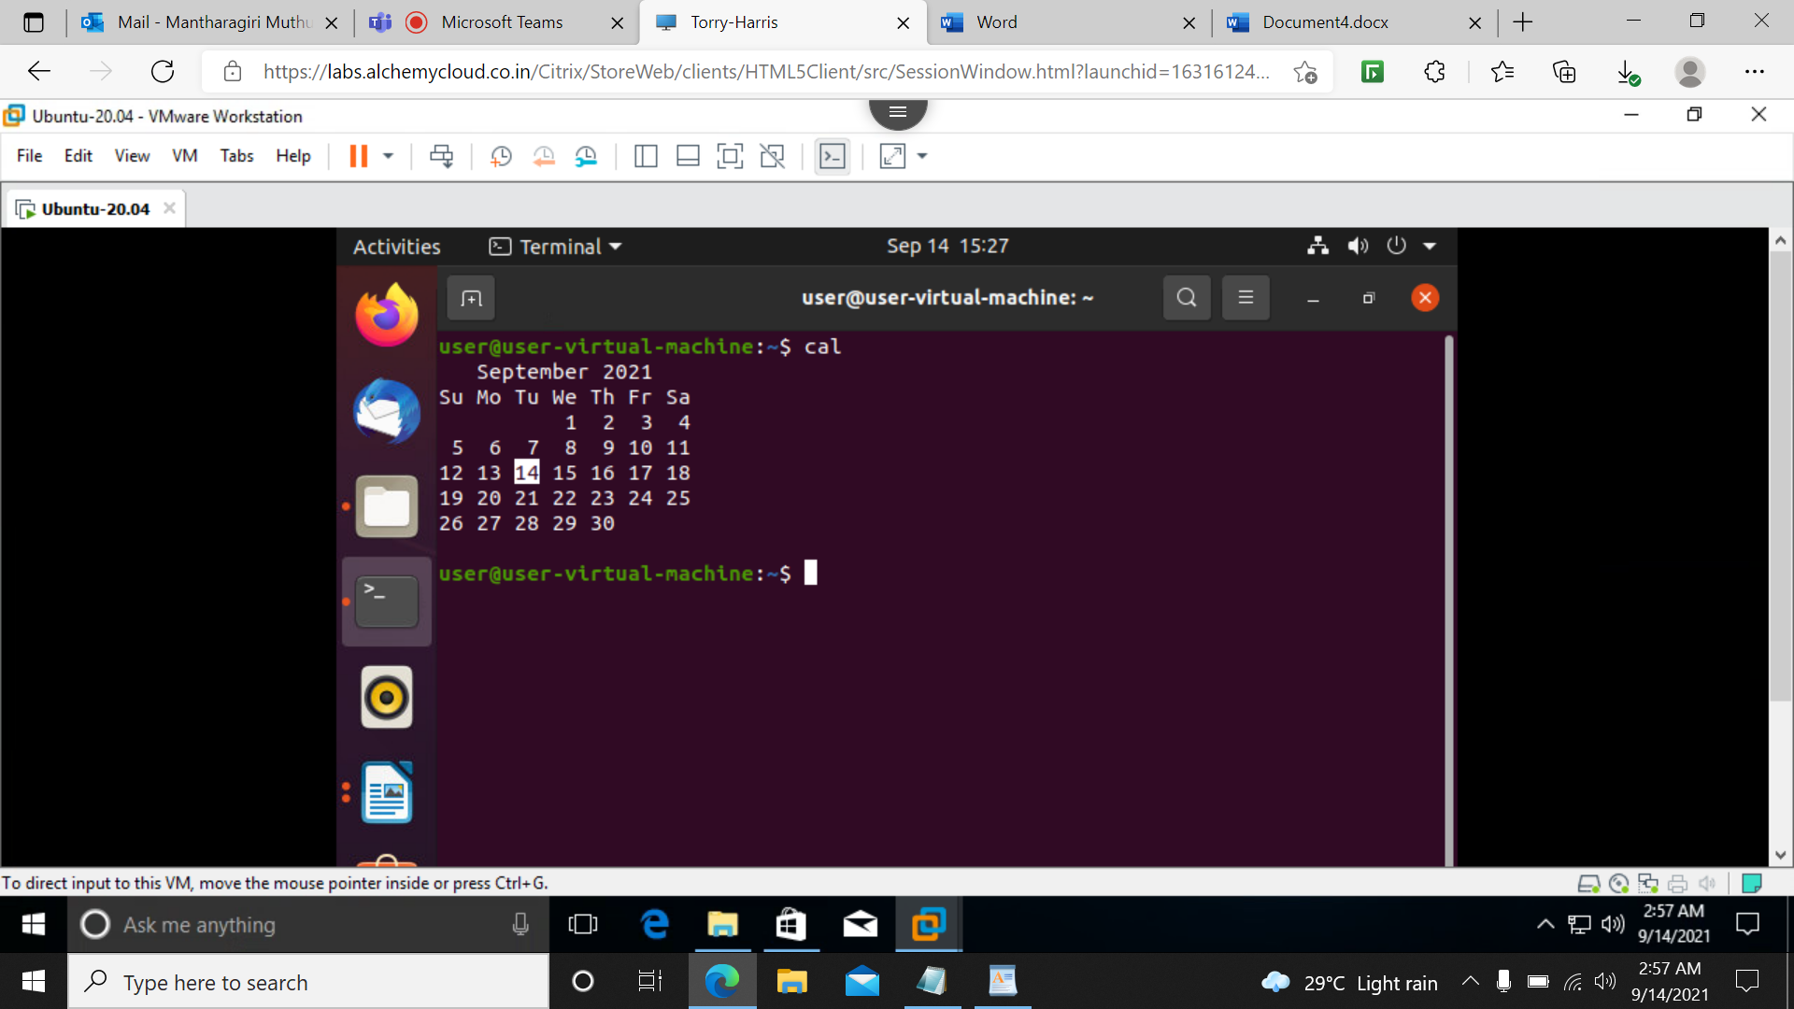

**28)passwd**

To change the password oof the current user.

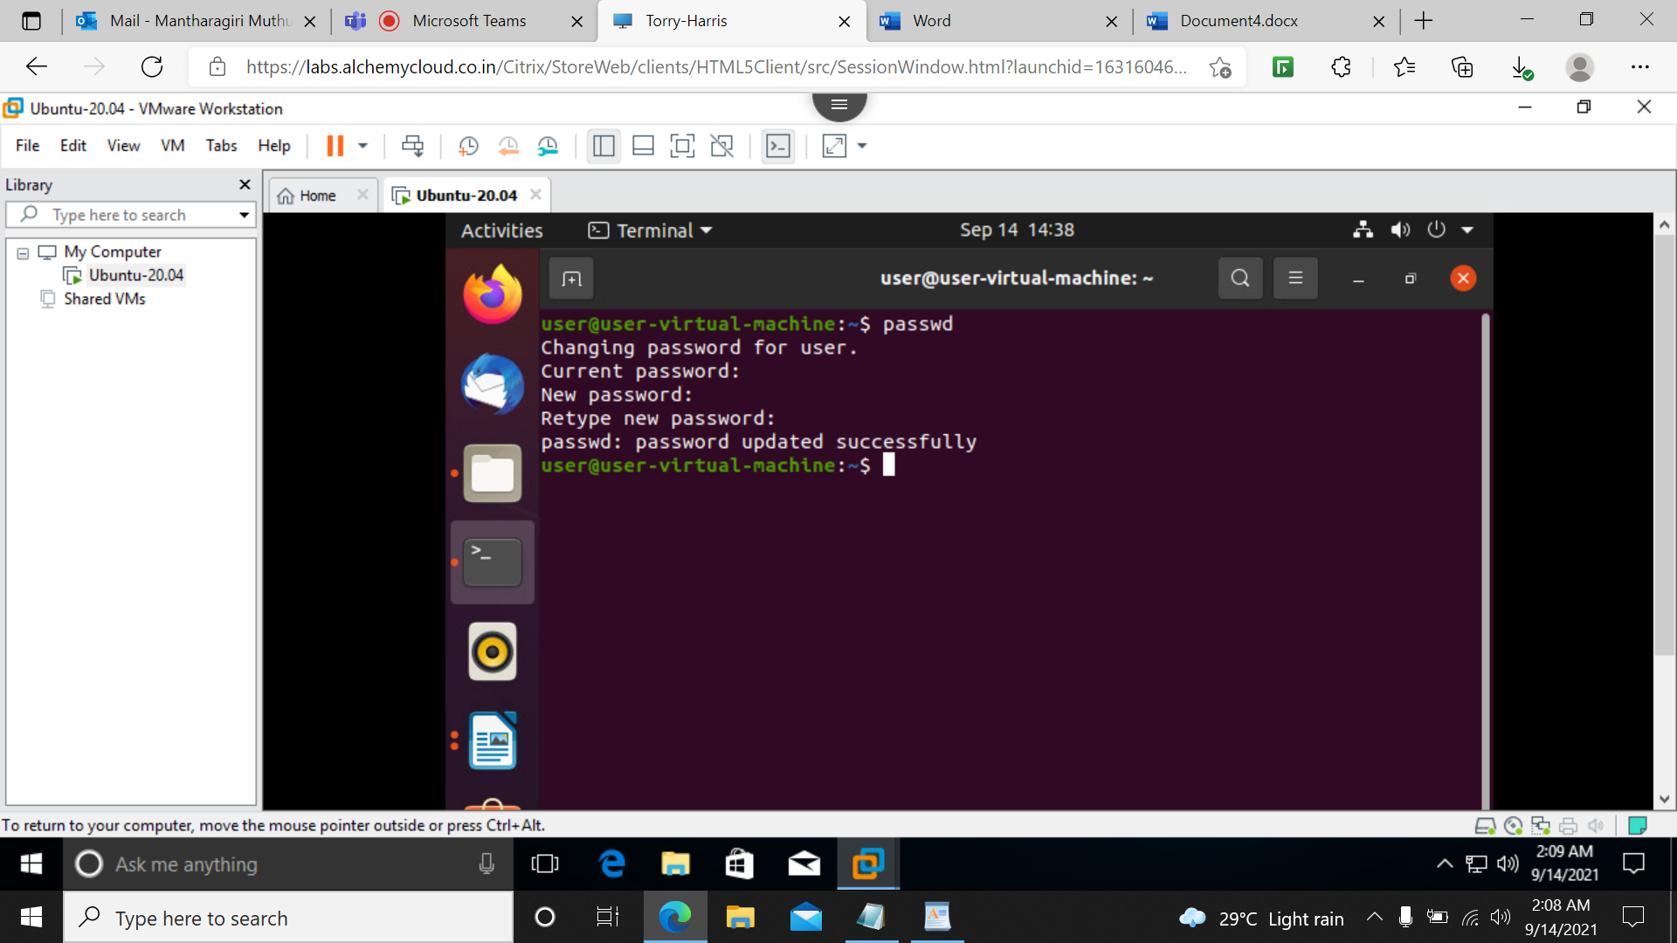

**29)ls -A**

Ignore . and .. hidden files and shows the remaining files.

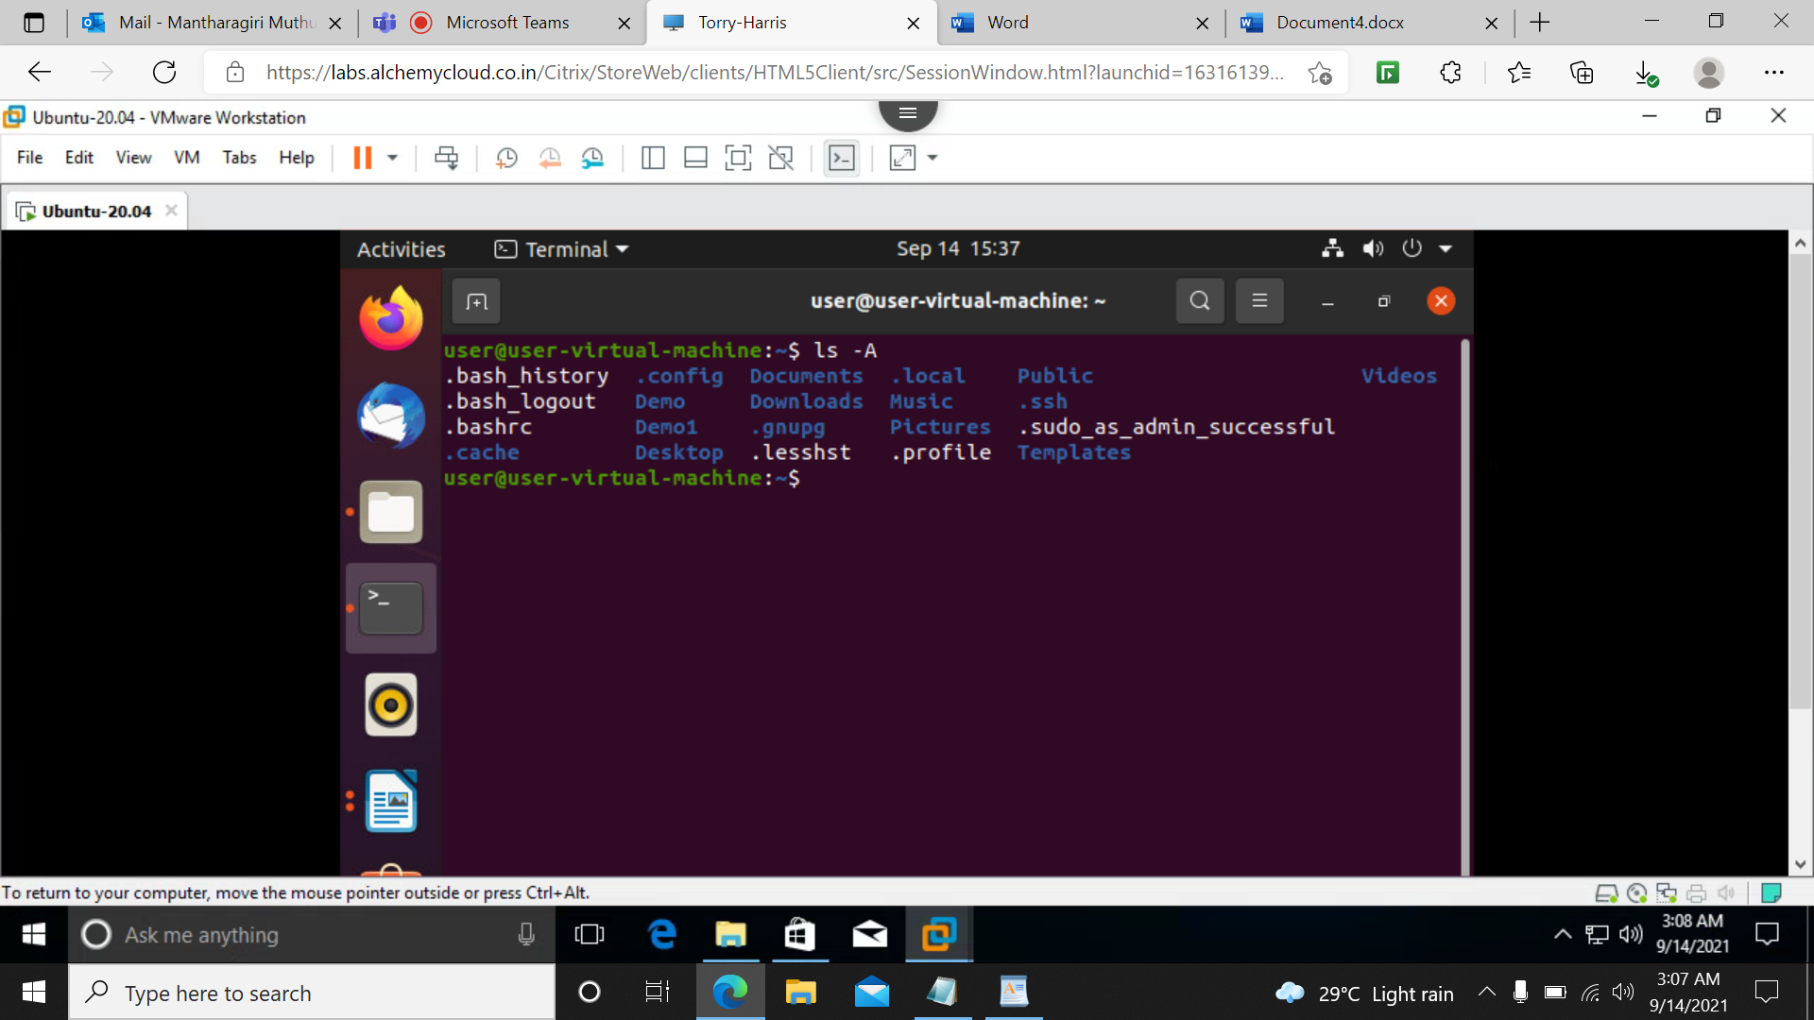

**30)tree**

It display the directories and files in a hierarchical format.

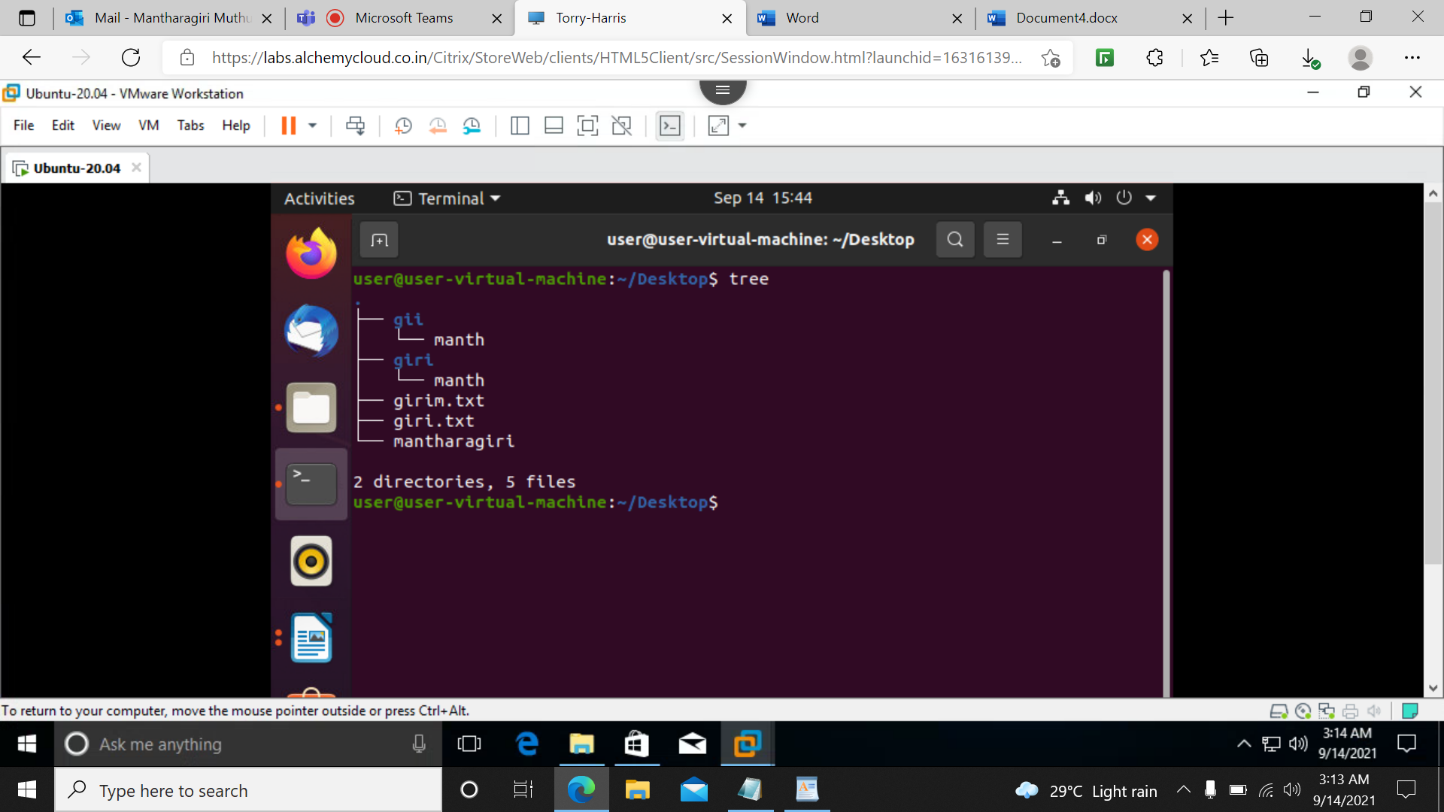

**31)tree –d**

It display display only the directory,it does not display files.

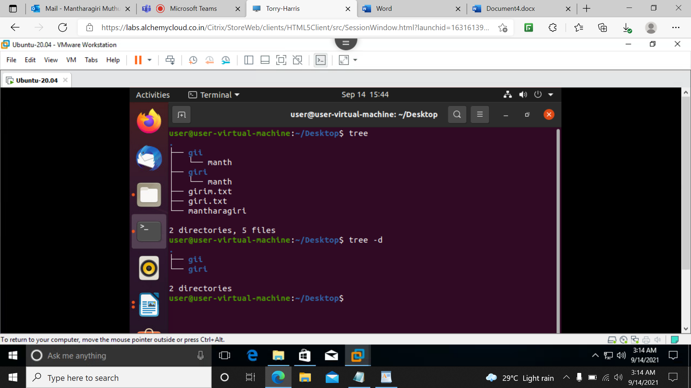

**32)mv**

It cut the file from one place and paste into another place.

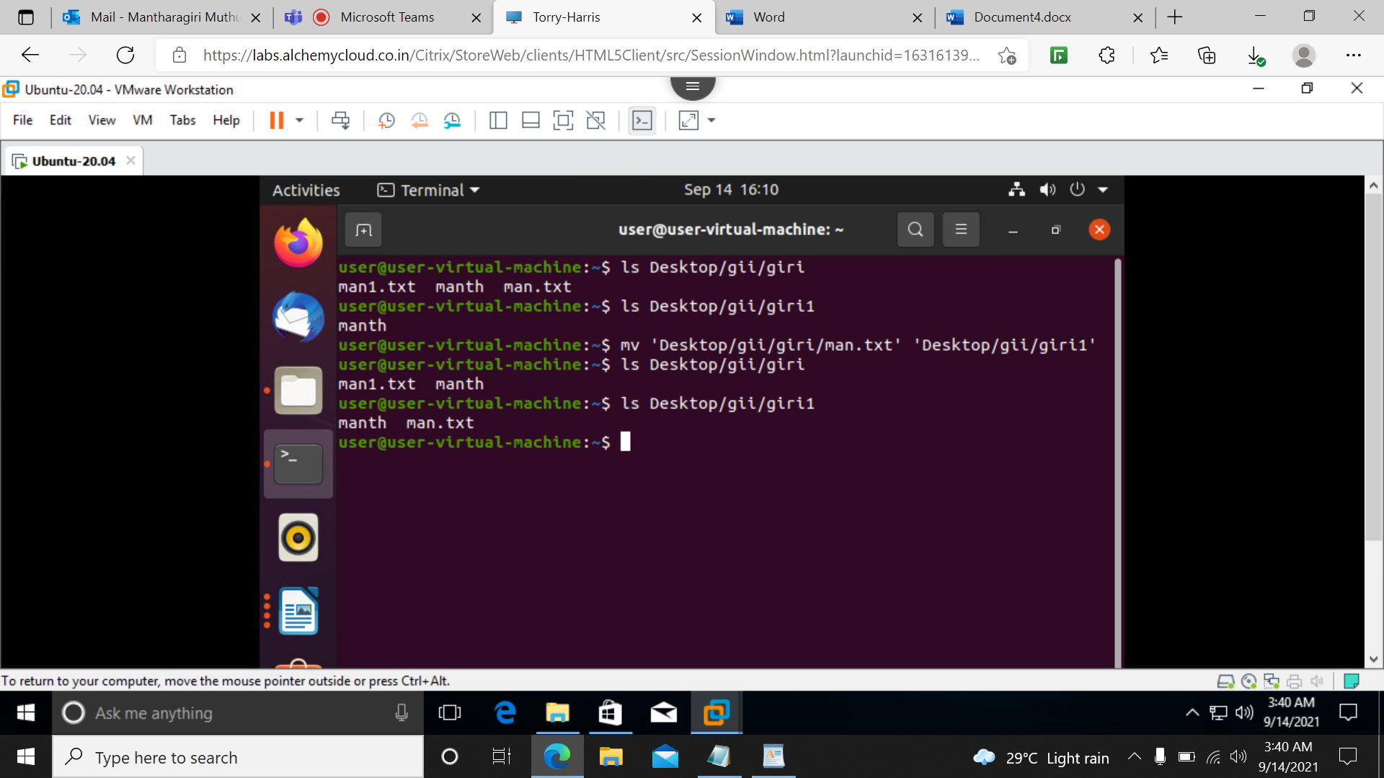

**33)cat filename filename**

It print all the datas from all the files

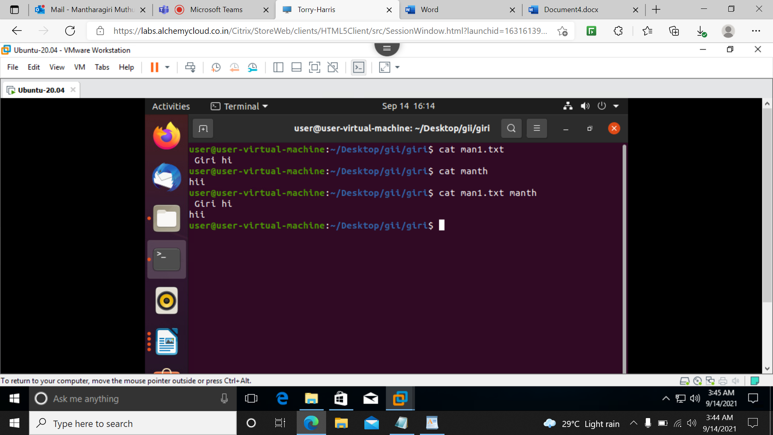

**34)--help**

It gives more information about the command. For example,if we give tree –help,it display more information about tree command.

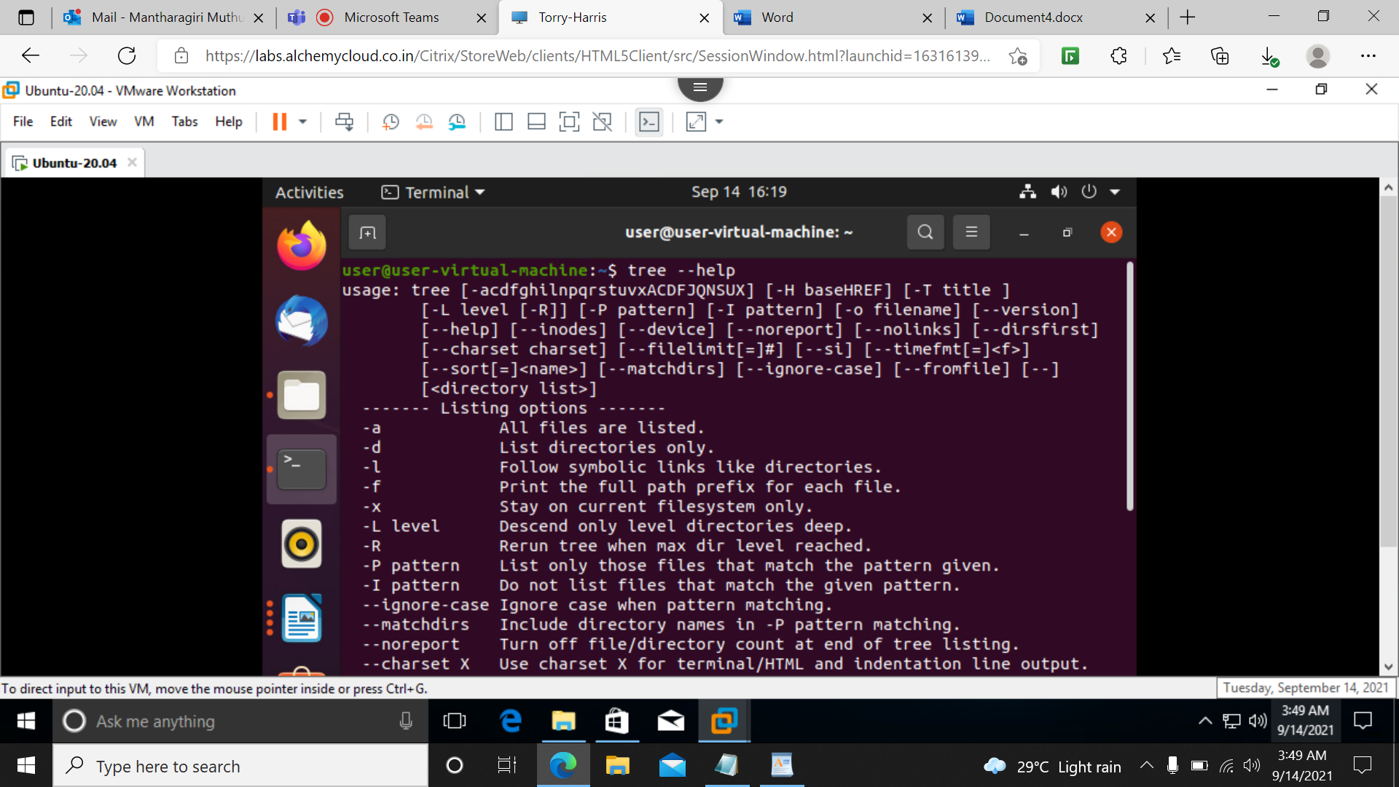

**35)mkdir –p a/b/c**

It will make many folders as 1 2 3 inside one another.

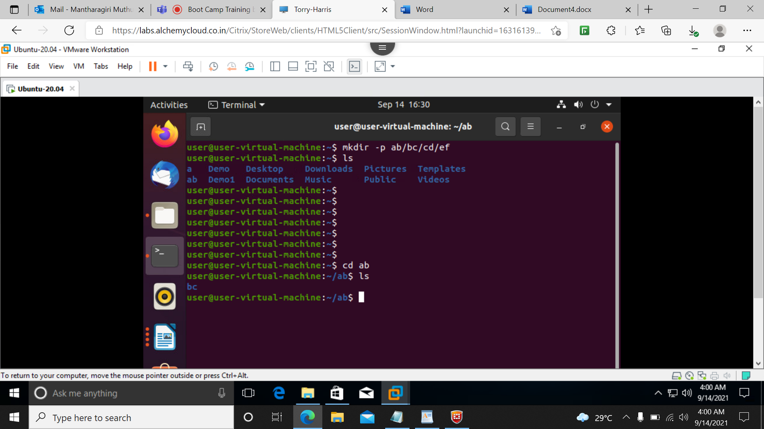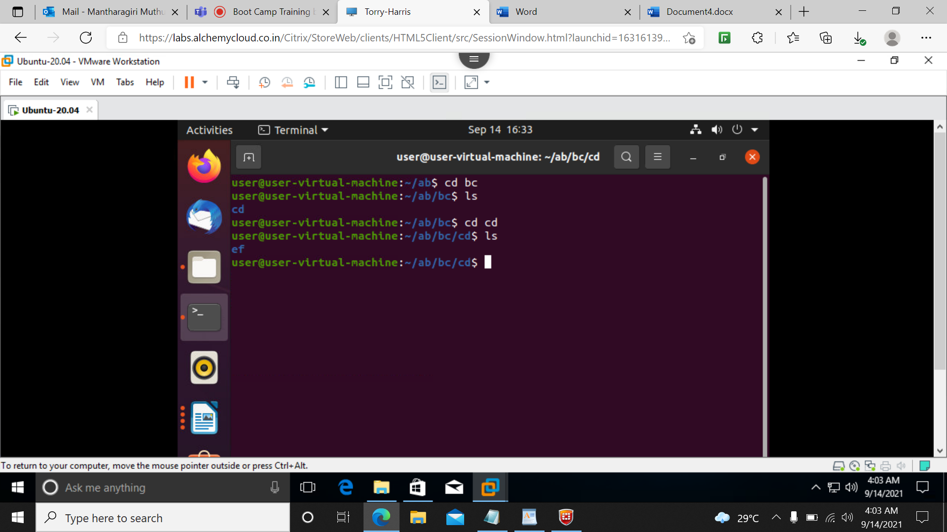

**36)rm –rf 1**

It will delete all the folders inside the 1 along with 1

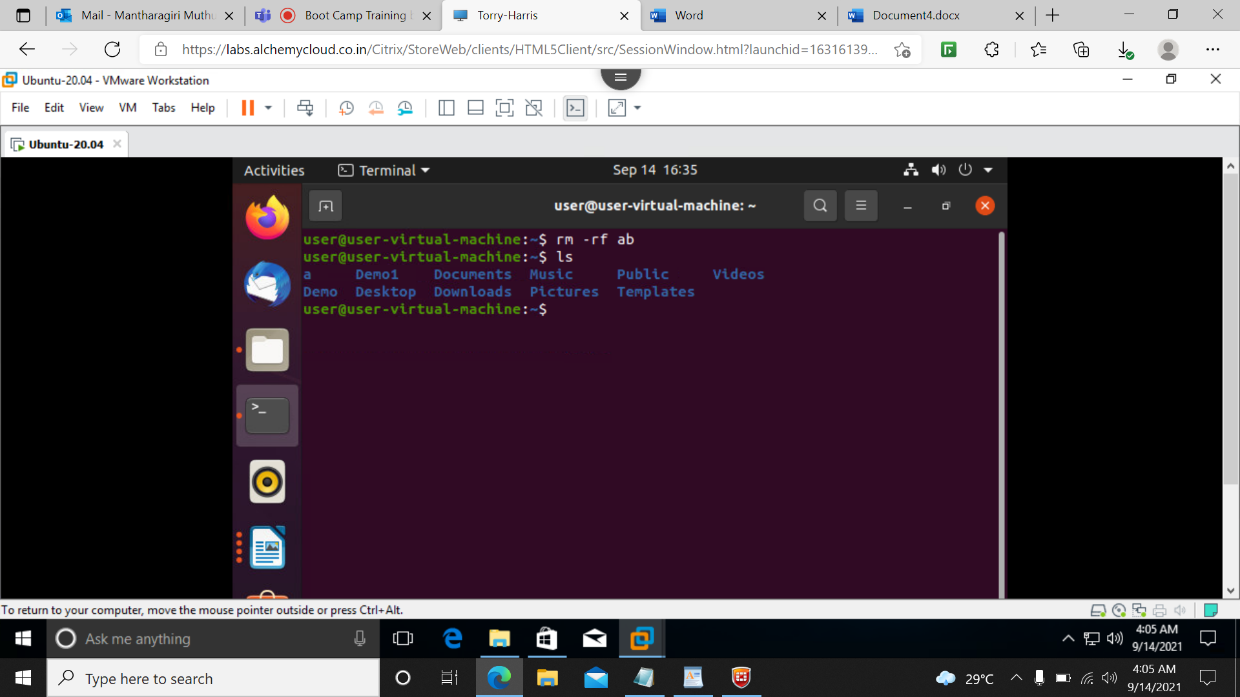

**37)cp a b**

It will copy the content from a to b.

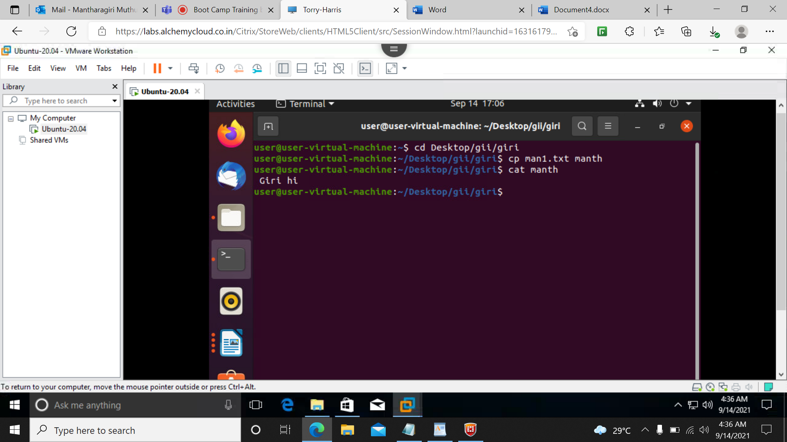

**38)mkdir demo{1,23}**

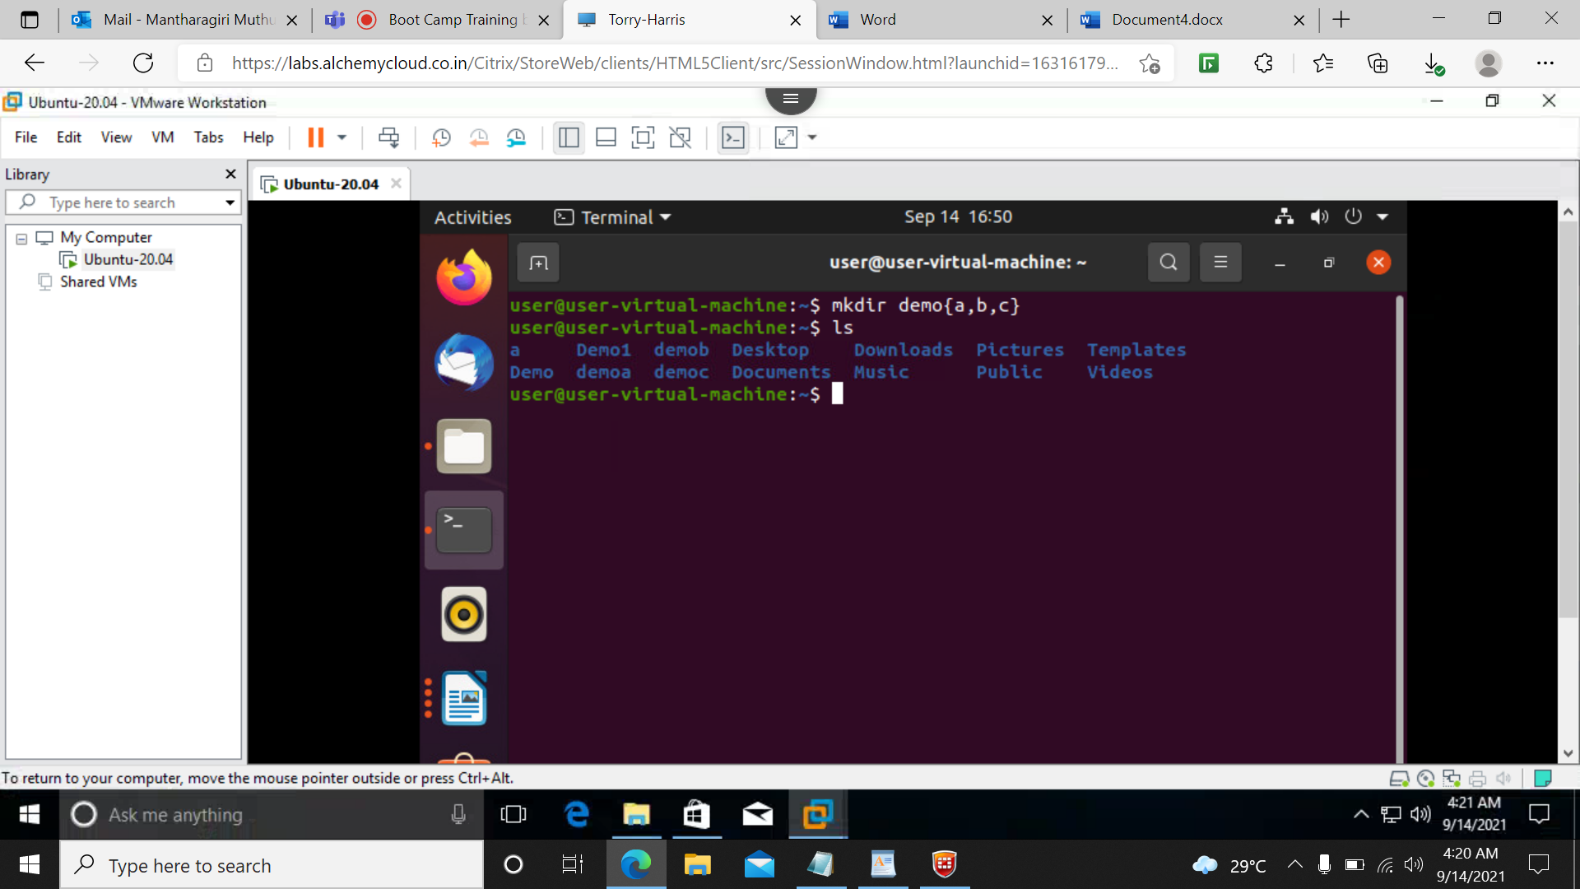

**39)sudo apt-get update**

It will download the upgraded things.

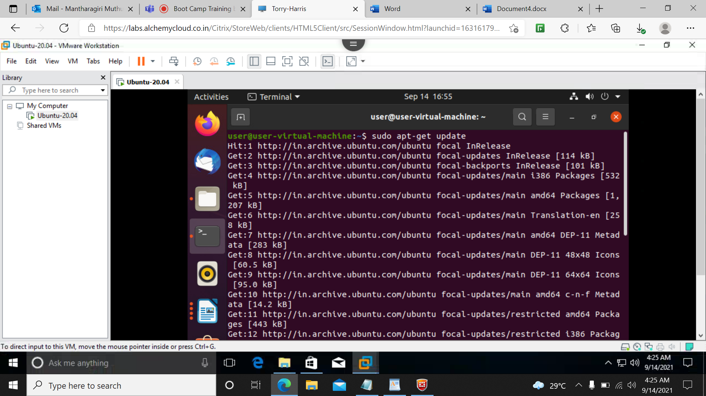

**40)sudo apt-get upgrade**

It will install the downloaded things.

